
Early Year’s Curriculum Intent
At Uplands we aim that our learners will gain the following skills from our curriculum. These centre around our Core School Values of kindness, resilience, creativity and respect and incorporate further specific aims for our Early Years Learners to achieve high outcomes
Play co-operatively SV Kindness
Show kindness and respect to others SV Kindness
Be creative in thought SV Creativity

Listen to others SV Respect
Link ideas to solve problems SV Creativity
Be resilient and persevere SV Resilience
Curriculum aims
Manage their personal needs
Hold conversations with others
Gain rich vocabulary
Be deep thinkers
Key stage 1 ready in key skills
Have self-awareness of who they are SV Respect
Show Independent skills
Lead a healthy lifestyle
Be confident and feel secure
Hold a sense of their community
Early Year’s curriculum goals
By the end of year R, we aspire that children reach the following curriculum goals
Communication and language | Personal social emotional development | Physical development
√ tell a story using sentences in the past tense and in sequence  √ partake in a 2-way conversation with a friend  √ describe themselves in detail and explain similarities and differences by answering questions  √ use new vocabulary  √ listen, do and respond in play | √ use own strategies to manage their emotions and calm independently  √embrace new challenges  √ play a shared game  √ cope with change and be confident to speak to others  √ manage all personal needs independently | √ ride a two wheeled bike (balance or pedalled)  √ have good posture when sitting (core strength)  √ use cutlery correctly to eat meals  √ handle pencils and scissors in a controlled way  √ climb, walk along, jump off, hop and skip

Literacy | Maths | Understanding of the world | Expressive art and design
√ write and read back complete sentences  √ Use spacing, full stops and capital letters  √ read simple sentences in a phonetically regular book using at least 10 digraphs | √ depth and breadth of numbers to 10 including bonds  √ compare quantities and measures  √ count objects, actions and sounds to 20 | √ talk about similarities and differences of things in the past and present  √ talk about how things grow and change | √ perform a song or dance to a small audience  √ create original ideas through art
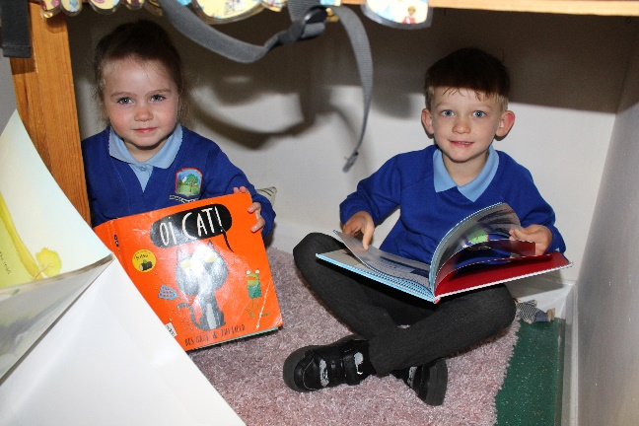
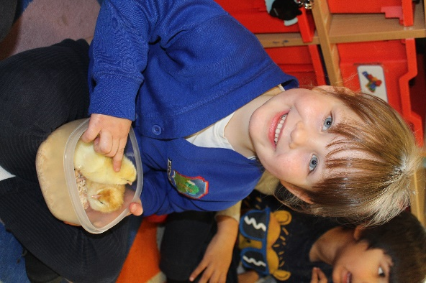
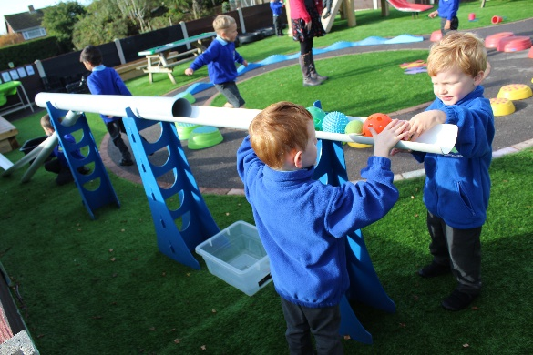
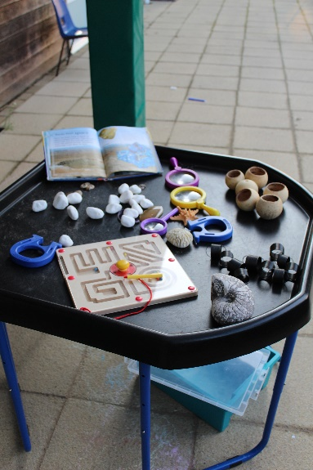

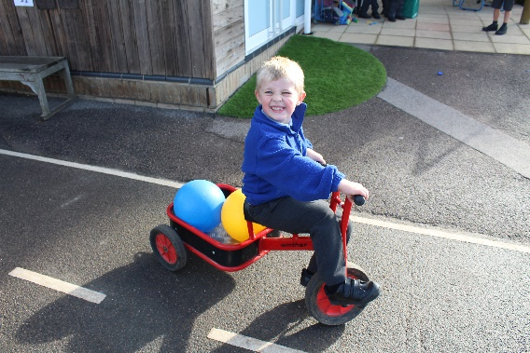

Early Year’s curriculum implementation
The following approaches will be used to support the curriculum
√ Daily story sessions with texts that are chosen to build familiarity and encourage reading for pleasure
√ Helicopter stories for confidence and communication development which will then lead into writing
√ enhanced small world play pockets in different areas of the environment
√ questioning for sustained thinking as adult enters the play – subtly listening and observing
√ Plan do review approach encouraged in child’s chosen play
√ Vocabulary rich talk – echoing child’s spoken word, repeating and adding. Vocabulary specifically identified.
√ text-based approach to environment themes and enhancements – books that add cultural capital, PSED, community, including non-fiction and poetry
√ Key person relationships for strong home/school partnerships – regular key person time to review learning and share star moments
√ planned food exploration to include growing, cooking, eating and to introduce healthy foods
√ Developing role play, dens and social/communication space to encourage talk
√ Daily phonics, number and literacy time
√ Floor books to capture learning and evaluation and to encourage child’s ideas to talk the learning forward
√ bump into books with chosen pockets of books to follow interests or develop play ideas
Early Year’s assessment, observations and recording
The following will support progress towards curriculum goals and a ‘good level of development’
√ Pre-school transfer information and teacher observations to help baseline on entry
√ Development Matters and own developed ‘observation points’ used as a check point for on track
√ Tapestry Journals for photos, WOW moments and next steps
√ Class notebooks to capture observations – contributed to by whole team
√ Class learning journeys and floor books to capture learning, thoughts, questions, and future lines of enquiry
√ Child’s Star Moment book to home/school celebration of key development points
√ Class displays for children to showcase their learning
√ Skills target boards in identified areas to support child’s next steps

